

Figure 1

**Axent Enhanced School Zone Signs (ESZS)**

Onsite Manual

AFDRS - Installation

Rev 1.0

# Document Control Form

|  |  |  |  |  |
| --- | --- | --- | --- | --- |
| Issue | | Date | Name | Change Details |
| Major | Minor |
| 1 | 0 | 28/04/2023 | Michael Lockhart | Document Creation |
|  |  |  |  |  |
|  |  |  |  |  |
|  |  |  |  |  |
|  |  |  |  |  |
|  |  |  |  |  |
|  |  |  |  |  |
|  |  |  |  |  |

Copyright © 2023 Axent Global

Axent Global (Axent) owns the copyright to this document and the information it contains, which are its exclusive property and are supplied in confidence. They must not be used for any purpose other than that expressly permitted in writing by Axent and must not be disclosed or reproduced without permission from Axent in writing.

Table of Contents

Document Control Form 1

Parts/Tools Required 3

PARTS 3

TOOLS REQUIRED 5

Processes 7

Installation of foundation 7

Instructions for Installing Solar Panel on a Pole: 9

Pole installation 9

1. Place the base of the pole on top of the foundation sleeve. 9

2. With the help of 2-3 people or a crane, have one person support the base of the pole above the sleeve while standing the pole and sliding it down into the foundation sleeve. 9

3. Orientate the pole so that the solar panel faces north. 9

4. Level the pole to ensure it is upright and straight. 9

5. Once the pole is levelled, tighten the grub screws, and install the gib key for secure attachment. 9

Sign Installation (Matrix) 9

Sign Installation (Rating Indicator) 10

Electrical connections and Test mode operation 11

1. Plug in the two solar connectors on the top edge of the rating display. 11

2. Plug in the two power connectors (2 Pin) and one data connector (4 Pin) between the rating display and matrix display. 11

3. Ensure that the pins are not bent or damaged during connection. Avoid plugging the connectors in at an angle to prevent bending the pins. 11

4. Once all the electrical connections are made, begin the Commission of the sign according to the provided commissioning document. 11

Commissioning 11

# Parts/Tools Required

## PARTS

|  |  |  |  |
| --- | --- | --- | --- |
| **Part** | **Part Number** | **Qty** | **Description** |
|  |  | 1 | Sign face – Rating |
|  |  | 1 | Sign Face – Matrix |
|  |  | 2 | NB80 Pole – 4700mm |
|  |  | 2 | Foundations |
|  |  | 2 | Solar Frame - 80NB |
| N0065E 65W 12V Monocrystalline Solar Panel |  | 2 | Solar Panel 80W |
|  |  | 4 | M12 x 152mm (80NB) U-Bolt - Gal |
| M12 x 1.75p Metric Coarse Galvanised Class 8 Hex Full Nut High Tensile AS1112 |  | 8 | M12 Nut - Gal |
| M24 (1") x 52mm x 4mm Galvanised Heavy Washers Low Tensile HEC Standard |  | 8 | M12 Washer - Gal |
|  |  | 2 | 2.5M SOLAR LEAD |
|  | 400071 | 6 | BATTERY 12V 21A Cyclic |
| FM125 | FM4-089 | 10 | 80NB POLE CLAMP |
|  |  | 10 | Pole clamp spacer - SHS |
|  |  | 10 | Pole Clamp spacer – Plate |
| M10 x 1.50p Metric Coarse Cup Head Coach Bolts & Nuts Class 4.6 Galvanised AS1390 |  | 20 | M10 x 60 Cup Head Bolt and Nut – Gal |
| M24 (1") x 52mm x 4mm Galvanised Heavy Washers Low Tensile HEC Standard |  | 20 | M10 Washers – Gal |
| M10 (3/8") Galvanised Spring Washers Low Tensile HEC 127B |  | 20 | M10 Spring Washers – Gal |
|  |  | 2 | Lifting Frame |
| M10 x 1.50p Metric Coarse Cup Head Coach Bolts & Nuts Class 4.6 Galvanised AS1390 |  | 4 | M10 x 25 Cup Head Bolt and Nut – Gal |
| 118-04700 |  | 10 | Cable Tie – 370 x 7.6mm |
| Bastion 20kg Quik Set Concrete - Bunnings Australia |  | 4 | Quick set concrete |
| Crusher Dust - Epsom Sand and Soil |  | 1/4M2 | Crusher Dust |
| Plain Stainless Steel Hex Socket Set M8 x 16mm Grub Screw | RS |  | 4 | M8 Grub screw |
| Sign Post Key - Gib Key Wedge | Jaybro |  | 2 | 8mm x16mm Gib Key |

## TOOLS REQUIRED

|  |  |
| --- | --- |
| Sidchrome 1/4" 21 Piece Drive Socket Set - Bunnings Australia | ¼” Socket Set   * 7mm socket * 8mm Socket |
|  | 1/2” Socket Set   * 16mm socket * 18mm socket |
| Stanley 20 Piece Acetate Screwdriver Set - Bunnings Australia | Screwdriver set. |
| IRIMO 5-450C-2 by Bahco Adjustable Shifter Wrench 450mm 18" - Spanners &  Wrenches, Wrenches, Wrenches Hand Tools - Discount Trader | Adjustable Wrench |
| Knipex Diagonal Cutter With Spring - 125mm - 7202125 | Supercheap Auto | Side cutters |
|  | 2 x 2M Platform Ladder |
|  | Allen Key set |
| TE 3000-AVR Heavy-duty electric jackhammer - Corded Demolition Hammers &  Breakers - Hilti Australia | Jack Hammer + Bits |
| fence bar hexagon | Crow Bar |
| Ergonomic Post Hole Shovel | Shovels & Spades | Shovel |
|  | 2 x 1.3t Concrete Lifting Clutch |
| Dy-Mark Spray & Mark Fluro Pink - 40013529 | Line Marking paint |

# Processes

## Installation of foundation

1. Locate installation location
   1. Refer to site plan for coordinates and proposed location
   2. Consult “Site location check list” for suitability
   3. If proposed site location is not suitable refer to Axent for further instructions
2. Check “Dial Before You Dig” plans before commencing any works
3. Mark out location of foundation closest to the road ‘Fog’ line
   1. Use line marking paint (typically “Pink”)
   2. Typical road offsets are:

|  |  |
| --- | --- |
| Road Speed | Distance from fog line |
| 60 kph | 3m |
| 80 kph | 6m |
| 100 kph | 9m |

* 1. Distance between poles is 1200 > 1300mm

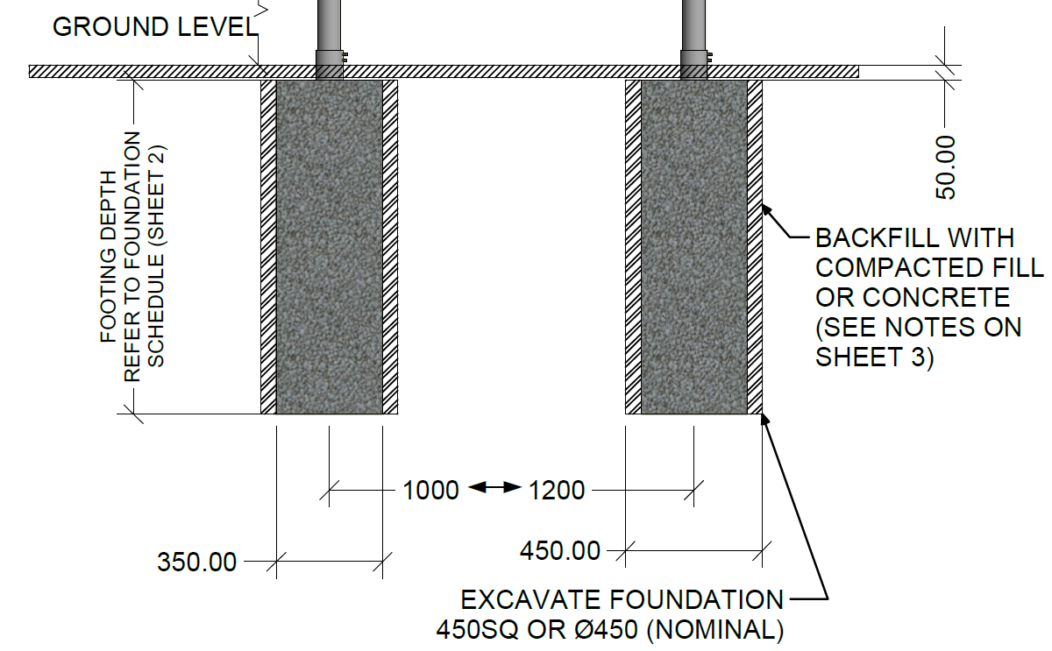

1. Excavate holes to depth shown below:
   1. Note: foundations are manufactured to 1100mm in length, so a hole of **1150-1200mm** is required

|  |  |  |  |
| --- | --- | --- | --- |
| FOUNDATION SCHEDULE | | | |
| REGION | EXPOSURE (TERRAIN CATEGORY) | SOIL TYPE | FOUNDATION LENGTH |
| A | Normal/Exposed (TC3/2) | Loose Sand to Stiff Clay | 1100mm |
|  |  | Rock | 900mm |
| B | Normal/Exposed (TC3/2) | Loose Sand to Stiff Clay | 1100mm |
|  |  | Rock | 900mm |
| C | Normal/Exposed (TC3/2) | Loose Sand to Stiff Clay | 1100mm |
|  |  | Rock | 900mm |

* If rock is encountered, the foundation can be shorted by 200mm

1. Install crushed rock base of 50-100mm compacted

1. Place foundations in excavated holes
   1. Do not back fill around foundations until they have been levelled with the poles
2. Attach solar panels to poles – Refer to section 2 for details
3. Install poles with solar panels into foundation sleeves
4. Level and square poles, ensure alignment at top of poles
   1. Ensure that alignment is checked side on from a distance

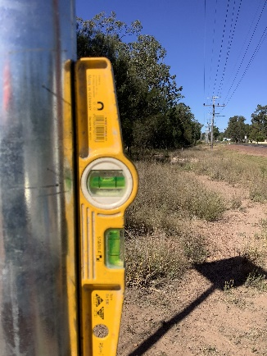

1. Back fill foundation with crush rock and quickset concrete (1 bag per foundation)
   1. Typically backfill ½ depth with crushed rock and water/compact in.
   2. Then backfill with 1 bag of quickset concrete
   3. Water in mixture
   4. Backfill to top of foundation with crushed rock and compact
   5. Ensure no voids are present in backfill by checking for compaction all around foundation

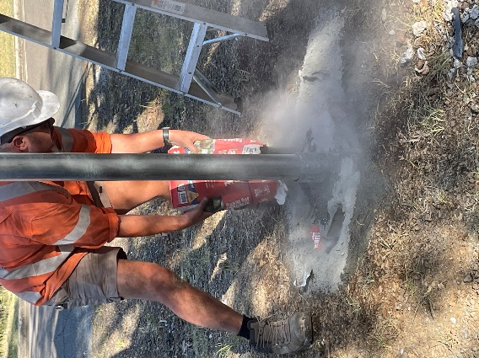

1. Check height offset between poles
   1. Max height offset between poles is 100mm
   2. Height can be adjusted by using a spacer placed in the foundation, min size for a spacer is 50mm and max size is 125mm

## Instructions for Installing Solar Panel on a Pole:

1. Ensure that the pole length falls within the range of 4.7 to 4.8 meters.
2. Position one end of the pole on a sawhorse or support structure, allowing for an overhang of approximately 1 meter.
3. Carefully place the solar panel at the top of the pole.
4. Install the "U-bolts" as depicted in the diagram provided and securely tighten them.
5. Use cable ties to fasten the solar cable to the top "U-bolt" for proper cable management.

Please follow these instructions carefully to ensure the safe and accurate installation of your solar panel on the pole.

## Pole installation

## Place the base of the pole on top of the foundation sleeve.

## With the help of 2-3 people or a crane, have one person support the base of the pole above the sleeve while standing the pole and sliding it down into the foundation sleeve.

## Orientate the pole so that the solar panel faces north.

## Level the pole to ensure it is upright and straight.

## Once the pole is levelled, tighten the grub screws, and install the gib key for secure attachment.

## Sign Installation (Matrix)

1. Open the matrix package but leave the matrix in the box for the following steps.
2. Install 4 sets of mounting hardware on the rear of the sign face using the provided components (80NB POLE CLAMP, Pole clamp spacer - SHS, Pole Clamp spacer - Plate, M10 x 60 Cup Head Bolt and Nut - Gal, M10 Washers - Gal, M10 Spring Washers - Gal).
3. Remove the matrix from the packaging and install it on both poles at chest height. It is recommended to only install the top pole clamps at this stage.
4. Lift the matrix to the required height of 2100mm above ground level.
5. Level the sign and tighten the top clamps securely.
6. Install the lower clamps to ensure stability and proper alignment.

## Sign Installation (Rating Indicator)

1. Open the fire rating package but leave the fire rating display in the box for the following steps.
2. Install 6 sets of mounting hardware on the rear of the sign face using the provided components (80NB POLE CLAMP, Pole clamp spacer - SHS, Pole Clamp spacer - Plate, M10 x 60 Cup Head Bolt and Nut - Gal, M10 Washers - Gal, M10 Spring Washers - Gal).
3. Once the wiring is complete, rotate the batteries and install the battery clamps securely. 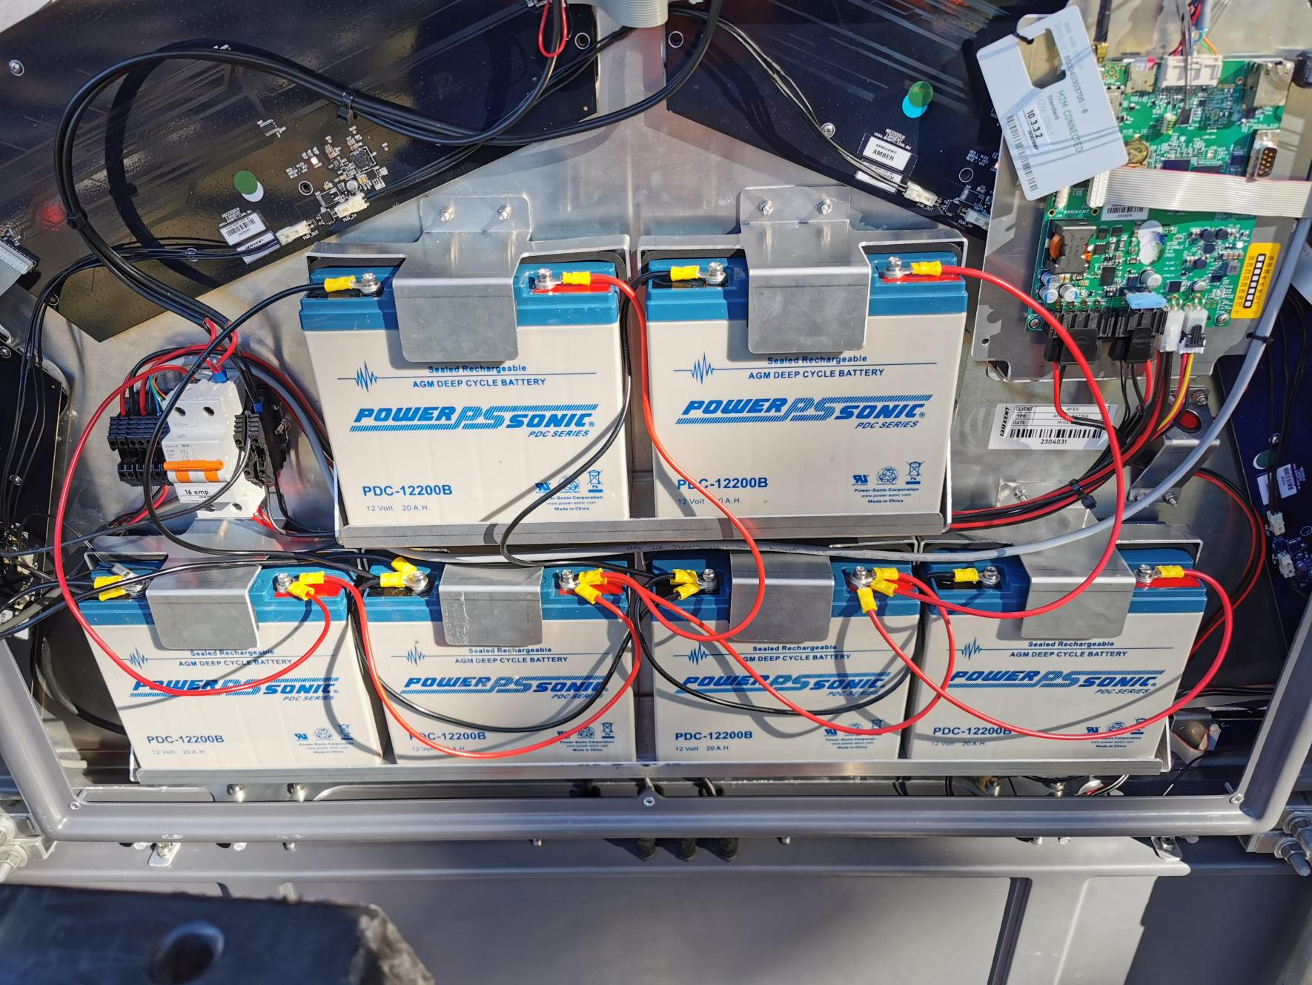
4. Ensure that the battery terminals are parallel to the batteries to avoid interfering with the rear door.
5. Install the lifting brackets.
6. Using a crane, lift the rating display up to the poles above the matrix display.  
   A picture containing outdoor, sky, tree, clothing

   Description automatically generated
7. Lower the rating display down so that it sits on top of the matrix display without any gap between the sign faces.  
   A picture containing outdoor, sky, tree, person

   Description automatically generated
8. Install and tighten the pole clamps to secure the rating display.

## Electrical connections and Test mode operation

## Plug in the two solar connectors on the top edge of the rating display.

## Plug in the two power connectors (2 Pin) and one data connector (4 Pin) between the rating display and matrix display.

## Ensure that the pins are not bent or damaged during connection. Avoid plugging the connectors in at an angle to prevent bending the pins.

## Once all the electrical connections are made, begin the Commission of the sign according to the provided commissioning document.

## Commissioning

Refer to onsite commissioning document for further instructions.

** end document**